

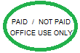
REGISTRATION FORM

VEG MEAT

Registration Date: _______________
Starting Date: _______________
Part Time Full Time :
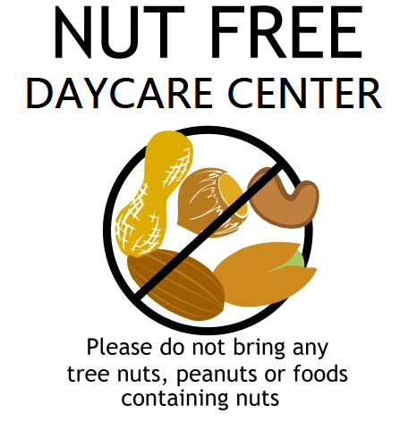
GENERAL INFORMATION

Childs name: ____________________________ Date of Birth:_____________________
Mother’s name: _________________________ Marital status: _____________________
Address: ____________________________________________
Home Phone No.: __________________ Work: _______________
Mobile: ________________ Place of Work: ________________________________
Occupation: ____________________ Hours of Work: ______________________
Father’s Name: ______________________ Marital status: ________________________
Address: _____________________________________________________________
Home phone No.: ________________ Work: _________________
Mobile: ________________ Place of Work: _________________________________
Occupation: ____________________ Hours of Work: _______________________
Emergency Contact: ___________________ Ph. No. : ___________________________
Relationtochild:___________Address:________________________________________________
Immunization up to date YES / NO Child staying with MOM / DAD / BOTH / ____________
Allergies YES / NO if any ________________________
Family Doctor: ________________________ Address: ______________________
Ph. No: _______________________ Alberta Health Care No: __________________
Parent/Guardian’s Email ID for communications_________________________________

Parent’s Signature: _________________________________Date: _________________

CHILD’S INFORMATION

- Child will arrive at center @ _________________Child will be picked up @ ______________
- Previous Experience in daycare centers : Yes ____ No ____ If yes, please describe the name of the daycare day home and the phone number ________________________________________________________________________________________________________________________________________________
- Child’s personality & Characteristics (shy, outgoing, fears ) ____________________________________________________________________________________________________________________________________
- Favorite activities : _________________________________________________
- Child’s typical reaction to illness, will he/she tell us? __________________________________________________________________
- Child’s typical reaction to Stress: __________________________________________________________________
- Favorite food: ______________________________________________________
- Does the child require a special diet for medical reasons? Yes ____ No____
Vegetarian / Lacto, Vegetarian, Vegans. Please describe: _______________________
(IF YES Please provide your own food.)

- Any allergies or recurring medical problems: __________________________________________________________________
- Child is toilet trained : Yes _____ No _____
- Names & ages of brothers and sisters: __________________________________________________________________
- Parents method of discipline : __________________________________________________________________
- Alternate person to escort from daycare: Name: _____________ Ph.: __________
- Names of persons whom are excluded from access to your child : ________________________________________________________________
- Additional Info. Daycare staff should be aware of : interests, any special needs & goals for your children _____________________________________________________________
___________________________________________________________________________

Parent’s Signature: _________________________________Date: _________________

GETTING TO KNOW ABOUT CHILDREN’S BACKGROUND
Child’s name : Parents name :

Country of Origin : Languages spoken &known
( home language)
Cultural Background
Items to share with the centre
Special cultural / religious events you celebrate:
Special comments if any:

PLEASE ADD FAMILY PICTURES AT THE BACK

Child’s Medical History

Note: Put _____inside themeans YES, & state the date on the line, please.

Immunization:

Diphtheria Polio Measles HIB shot Pertussis(whopping cough) rubella
Tetanus Mumps
AGE

2months _________ ________

4months _________ _______
Primary:
6months
________ ________
12months
__________ _______
18months

Booster : 4 – 6 Years _________ _______

Put______inside if your child had any of the following conditions or diseases?

Rubella Diabetes Convulsions

Measles jaundice Epilepsy

Mumps Allergies Head Injury

Chicken pox Heart Conditions poisoning

Whooping cough Tuberculosis Surgery

List surgeries, accidents traumatic experiences, congenital defects and special problems
ear ache, speech, vision,hearing,feeding/eating,sleeping,bowels,wetting,etc ____________________________________________________________________________________________________________________________________________________________________________

Has this child had any medical or emotional conditions requiring/receiving treatment? Yes _________ NO_____________.
If Yes please explain_______________________________________________________ ________

Is the child on daily medication? Yes ______ No________ if yes please give name of the medication ___________________________________________________________________________
List any other information that will aid us in working more effectively with your child ____________________________________________________________________________________

Parent’s Signature_________________________________ Date:_______________________
Terms & Agreements

- The Daycare is open from 7.00 am and Closes at 6.00 pm. It is unfair to both your child & daycare staff to be detained after that time. Parents arriving after 6.00 pm will be charged $20.00 for the First 5 minutes and $1.00 per minute there after.
- Monthly fees are DUE on 1st of EVERY MONTH [if 1st happen to be holiday then it is due on the first next working day]& also payable visa/MasterCard; or DEBIT We now have a DEBIT/Credit machine on premises.
- A $ 50.00 NON REFUNDABLE one time registration fee is required upon the time of registration.
- A $35.00 charge will be levied on all NSF Cheques.
- Overdue accounts will occur an interest charge of 10 % per month.
- NO REFUND will be made for statutory holidays, sick days, or days absent. However, the center will allow$ 20.00 per week deduction for annual vacation (max-3-weeks).
- Parents may withdraw their child from the center at anytime provided one month notice is served in advance to the center.
- Medication cannot be administered to any child without a Valid Doctor’s prescription for the particular child for whom it is intended and without signatures on the posted medication chart.
- To avoid cycles of illness at the center, parents are required to keep children away from the center if they have communicable illness or disease.
10 Should any child sustain an injury or illness while at the center we will
A) Attempt to contact the parent immediately
B) Take the child to a Dr. or Hospital for treatment.
It is the responsibility of the parent to pay for the costs of the ambulance as well treatments if any.
11. If your child will be absent from the center, pl. phone and inform the center in advance.
12. The center reserves the right to remove from its enrollment any child who is persistent in distracting the progress of the group.
13. WE will use all care in caring for your children and their possessions. However, the center will not be responsible for any loss of possession, any injury, accident, sickness, or illness or disease that may occur to any child while in the center.

I fully read and agree to abide by the above regulations of the center.

Parent signature: __________________________Date: _________________

A $25.00 PER CHILD- CAUTION DEPOSIT [FULLY REFUNDABLE** WHEN CHILD IS TAKEN OFF THE CENTRE ]
IS NEEDED FOR THE SAFETY OF THE STAFF AND CHILDREN.ONCE THE CHILD IS REGISTERED-THE REGISTRATION FEE AND THE DEPOSIT WILL NOT BE REFUNDED .
THE $ CAN BE USED FOR THE COMING MONTH(S)
** PROVIDED THE SWIPE CARD BE IN GOOD SHAPE& REUSABLE.



Authorization for walks
I_____________________________hereby authorize the staff of Summerside child care center, to take my child___________________ on spontaneous walks and to near by parks of the licensed premises.

Signature of the parent/Guardian_________________________Date____________
===========================================================================
SUNSCREEN & BUG SPRAY POLICY

I (parent) ____________________ give Summerside child care center, permission to apply sunscreen, bug spray on my child ___________________ whenever necessary. ( sunscreen& bug spray’s are provided by parents)
Signature of the parent/Guardian_________________________Date____________

Parent Acknowledgement of Policies

I, ____________________________________ (parent name) have read, understand and agree to comply with all of the policies contained in the Parent Handbook. I understand that at any time I can have access to detailed procedures for policies and additional policies contained in the Policy and Procedures Handbook and that feedback from families on the centre’s polices is encouraged and will be taken into consideration for updating policies.

Parent signature _______________________________ Date: _____________________

PHOTO GRAPH - CONSENT FORM POLICY

We_________________________ here by authorize the Summerside Child Care center and its staff to take pictures of our child/ children and used only in the child care center, and NOT out side or for any commercial purposes.

Parent signature: ________________________Date: _____________________
===========================================================================
VOLUNTEER – CONSENT FORM
I / We ___________________parent/grand parent of _____________(child’s name) would like to volunteer for the Summerside child care center ,during the field trips, special occasions or on a daily basis a and when required .
Circle the ones suits : a) Police clearance YES/ NO b) time available M-T-W-T-F- ( __AM TO __PM)

Parent/ grand parent signature________________________Date:________________________

OTHER PROFESSIONAL AGENCIES
I / we give permission to Summerside Childcare to share the information of my/our child ________________
Age___________ with other professional agencies. It is deemed with best interest of the child/children.

Parent / guardian signature …………………………Date……………………

Dear Parents,

Nipissing dist developmental screen has developed a skill concept checklist to monitor your child’s development for the toddler’s ages 12 months ,15 months ,18 months ,2 years and 30 months,3 years,4 years,5 7 6 years.

The check list includes cognitive, language, social, math and science, gross and fine motor skills. These are done ONCE a year.

You are welcome to inquire about this checklist. These checklists are developed to help us better support the children in our care.

Please fill in the form below,

I __________________ give Summerside Child Care Center permission to observe my child _____________age_______ for the self concept checklist.

Parent / Guardian signature:__________________________

=============================================================================

Updated Mar 24th 2017

Parent Orientation Checklist

- ____________________ Received Parent Hand Book

- ____________________ Tour of the Daycare centre

- ____________________Completed registration form

- ____________________Reviewed Policies

- ____________________Notice of withdrawal

- ____________________Fee Policies

- ____________________Illness & Health Policies

- ____________________Developmental Screening & Consent form signed

- ____________________Goals for children discussed

- ____________________ Online News letter – semi monthly ( Hard copies are also available on request)

- ____________________ Learning Opportunities for children on the room doors

- ____________________ Daily reports in each room (12 mts- 3 yrs) [ what the child did today] like what children ate, nap, diapering etc., notes to parents and comments etc.,

I _____________read & understood & got explained of all of the above______________
(Name of the parent) (Signature) __________________ Date :___________________

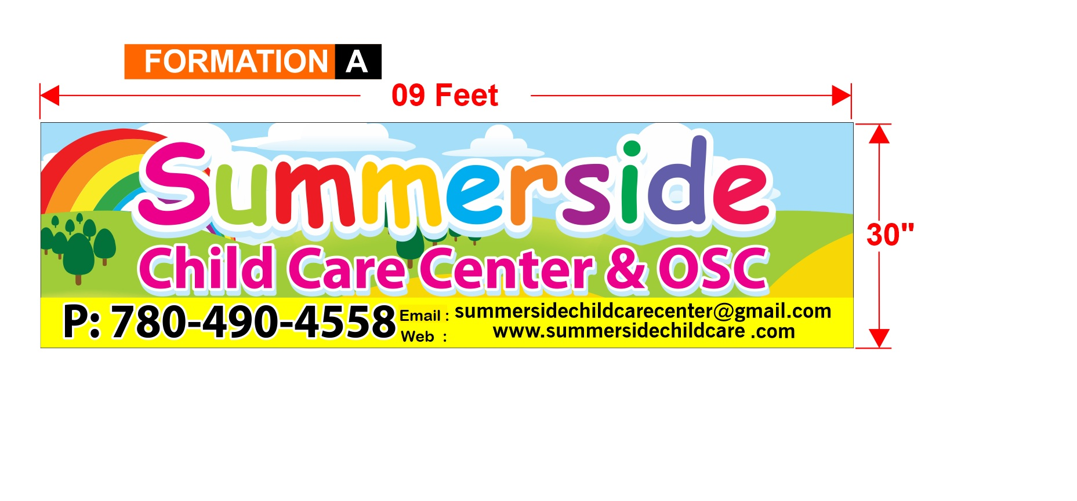

PRE-SCHOOL & DAYCARE PACKING LIST

PRE-SCHOOL
Bring a backpack with:
• Two snacks (lunch bags need to include an ice pack.)
• Water bottle
• A change of clothes with pants, shirt, underpants, and socks in a Ziploc bag. (We encourage you to dress your child with clothes without belts, ties, difficult to manipulate buttons/zippers, etc.)
• A clean pair of indoor Velcro footwear to wear as inside shoes. (They need to go home every day.)

DAYCARE
Bring a backpack with:
• Two or three snacks (lunch bags need to include an ice pack.)
• Lunch (healthy nutritional food please, you can bring dinner’s leftovers, sandwiches, pasta salad, etc.)
• Water bottle
• 1 small non-toxic** plant (Caring for plants is a good first step in taking responsibility for another living being.)
• A change of clothes with pants, shirt, underpants, and socks in a Ziploc bag. (We encourage you to dress your child with clothes without belts, ties, difficult to manipulate buttons/zippers, etc.)
• A small blanket and a favorite stuffed animal for nap time in a bag with a zipper.
• A clean pair of indoor Velcro footwear to wear as inside shoes and to be left in the child’s cubby (Slippers, crocs or bare feet are not permitted)
• Summer: A hat, sunscreen and insect repellent (NO aerosol cans are allowed)
• Winter: Toque, waterproof mittens, snow pants, coat, extra socks, snow boots (we recommend leaving a spare set of winter clothes at the daycare so that you don’t have to carry all items back and forth.)

IMPORTANT:
• No toys are allowed as The Kids Place will not be held responsible for any lost or damaged toys.
• Please label every item in your child’s bag.
• Slippers, crocs or bare feet are not permitted.
• ** Examples of non-toxic plants: African Daisy, African Violet, Bamboo, Boston Fern, Gardenia, Petunia, etc.

